Data Engineer Intern Assignment
A.B.T.Perera

CONTENT
1 Executive Summary 5
2 Objectives And Scope 7
3 Dataset Overview 8
3.1 Files Used 8
3.2 Main Entities 9
3.3 File Relationships 9
3.4 Primary And Foreign Keys 10
3.5 Important Columns 10
3.6 Data Quality Observations 11
3.7 Dataset Limitations 11
3.8 Assumptions 12
4 Methodology 13
4.1 Overall Approach 13
4.2 Dataset Familiarization 13
4.3 ETL Methodology 14
4.4 Data Quality Methodology 14
4.5 Data Cleaning Methodology 15
4.6 Data Enrichment Methodology 15
4.7 Data Modeling Methodology 16
4.8 Exploratory Analysis Methodology 16
4.9 Statistical Analysis Methodology 16
4.10 Data Science Methodology 17
4.11 Open Innovation Methodology 17
5 Engineering Approach 18
5.1 Folder Structure 19
5.2 Pipeline Design 20
5.3 Data Ingestion 21
5.4 Data Quality Checks 21
5.5 Cleaning And Standardization 21
5.6 Enrichment And Joining 22
5.7 PostgreSQL Data Model 23
5.8 SQL Analysis 23
5.9 Pipeline Automation And Logging 24
6 Exploratory Data Analysis Findings 26
6.1 Overall Listing Summary 26
6.2 Price Distribution 26
6.3 Price By Room Type 27
6.4 Neighbourhood Price Differences 28
6.5 Availability And Estimated Occupancy 29
6.6 Host Activity 31
6.7 Review Score Patterns 31
6.8 Review Count As A Demand Indicator 32
7 Statistical Findings 33
7.1 Statistical Testing Approach 33
7.2 Hypothesis 1: Entire Homes Vs Private Rooms 33
7.3 Hypothesis 2: Superhost Vs Non-Superhost Review Scores 34
7.4 Hypothesis 3: Listings With More Reviews Vs Fewer Reviews 35
7.5 Hypothesis 4: Price Differences Across Major Neighbourhoods 35
7.6 Hypothesis 5: Weekend Vs Weekday Prices 36
7.7 Summary Of Statistical Findings 36
8 Data Science Experiment - Price Prediction 37
8.1 Features Used 37
8.2 Models Compared 37
8.3 Model Results 38
8.4 Interpretation 38
8.5 Limitations 39
9 Open Innovation Challenge 40
10 Business Recommendation 42
10.1 Use Median Price For Market Benchmarking 42
10.2 Price Listings Based On Room Type 42
10.3 Consider Neighbourhood-Level Pricing 42
10.4 Treat Occupancy And Revenue As Estimates 43
10.5 Improve Listings With Many Reviews But Lower Ratings 43
10.6 Use Price Prediction As A Support Tool, Not A Final Decision Tool 43
10.7 Focus On Practical Pricing Drivers 43
10.8 Summary Of Recommendations 44
11 Cross-City Comparisons 45
12 Limitations & Caveats 46
13 Future Improvements 47
14 Reflection 48
Appendix A: AI Usage Disclosure 49

EXECUTIVE SUMMARY
This project is about creating a simple and reproducible data engineering and data analytics pipeline with the Amsterdam Inside Airbnb dataset. The primary goal was to transform raw Airbnb data into clean, structured, and analysis-ready outputs that would aid in the understanding of the market and business decisions.
The project used four main source files: listings, calendar, reviews, and neighbourhoods. These files were processed through a Python-based ETL pipeline. The pipeline checks raw files, profiles the data, performs quality checks, cleans and standardizes fields, joins related datasets, creates enriched analytical outputs, and loads structured tables into PostgreSQL.
The final dataset contained 10,480 Amsterdam listings. Out of these, 5,874 listings had valid price values available for price-based analysis. The median price for a listed home was 222.00 and the average price 336.79. This indicates that some expensive properties affect the overall average, so that the median is a more representative figure of a typical listing price.
The analysis results indicated that room type and neighbourhood are significant factors in the pricing of Airbnb. The cost of entire homes and apartments were overall higher than that of private rooms. The same was true at the neighbourhood level, as there were also clear price differences between neighbourhoods in Amsterdam.
Occupancy and revenue estimates were made using calendar data. The numbers are approximate, though, as unavailable calendar dates can be either booked dates or simply dates that are unavailable for hosts. In addition, the calendar price and adjusted price fields were not available, and thus a daily pricing and weekly vs. weekend price analysis was not possible.
A basic statistical analysis was performed to test selected patterns in the Airbnb market. The results confirmed that listing type, neighborhood, review activity and availability are useful factors in the understanding of Airbnb prices. We also carried out a simple price prediction experiment using Linear Regression and Random Forest model. The Random Forest model performed slightly better, but the experiment was treated as exploratory rather than production-ready.
A small open innovation output was also created as a rule-based market opportunity finder. It identifies value neighbourhoods, premium neighbourhoods, high-occupancy neighbourhoods, potential listing improvement opportunities, and top estimated revenue listings.
Overall, this project is a realistic end-to-end data flow from ingestion through to profiling, cleaning, enrichment, to a proper modeling of the data in PostgreSQL, to exploratory analysis, statistical testing, to some basic machine learning, and finally to business reporting. The project's greatest benefit lies in the transparent and repeatable way of deriving insights from raw public data to become useful for business.

OBJECTIVES AND SCOPE
The goal of this project was to develop a straightforward and repeatable data engineering pipeline with the Amsterdam Inside Airbnb dataset. The aim was to transform the raw public data into cleaned, enriched and analysis-ready outputs to help inform business insights into Airbnb pricing, availability, hosts, reviews and neighbourhoods.
Amsterdam was chosen as the city in which to perform this project. I selected a single city rather than multiple cities as there are a number of areas to assess, such as data engineering, exploratory analysis, statistical analysis, data science experiments and reporting. By narrowing my scope down to one city, I was able to write cleaner code, provide more thorough documentation, and do more analysis in the allotted time.
The scope of the project comprised the following aspects:
- Dataset exploration and file checking
- Data profiling and schema review
- Data quality checks
- Data cleaning and standardization
- Data enrichment and joining
- PostgreSQL data modeling
- Exploratory data analysis
- Basic statistical analysis
- Simple price prediction experiment
- Small open innovation output
- Final report and documentation
This project relied on four key Amsterdam Inside Airbnb files: listings, calendar, reviews and neighbourhoods. The files have been chosen as they give information on listing details, host details, availability, reviews, prices and geographic areas.
No multi-city comparison, advanced geospatial mapping, cloud deployment, Docker, dbt, dashboarding or advanced AI/LLM was done in the project.

DATASET OVERVIEW
The dataset used in this project is the Amsterdam city dataset from Inside Airbnb. Inside Airbnb provides publicly available Airbnb data for different cities, including listing details, calendar availability, reviews, and neighbourhood information. For this project, only Amsterdam was selected to keep the analysis focused and manageable.
The dataset represents Airbnb market activity in Amsterdam. It includes information about listings, hosts, prices, availability, reviews, and neighbourhoods.

Files Used
Four main files were used in this project.
File | Rows | Columns | Description
listings.csv.gz | 10,480 | 79 | Main listing data including listing details, host details, price, room type, location, availability, and review scores
calendar.csv.gz | 3,825,200 | 7 | Daily availability records for each listing
reviews.csv.gz | 501,084 | 6 | Guest review records linked to listings
neighbourhoods.csv | 22 | 2 | Amsterdam neighbourhood reference data

The listings.csv.gz file is the main dataset because it contains the core information about each Airbnb listing. The calendar.csv.gz file provides daily availability information. The reviews.csv.gz file contains guest review records. The neighbourhoods.csv file provides neighbourhood reference information for Amsterdam.

Main Entities
The main entities in the dataset are listings, hosts, calendar records, reviews, and neighbourhoods.
- A listing represents an Airbnb rental unit. It may be an entire home, private room, hotel room, or shared room. Listing-level fields include price, room type, property type, number of bedrooms, number of reviews, availability, and review scores.
- A host represents the person or business managing one or more listings. Host-related fields include host ID, host name, host since date, superhost status, and the number of listings managed by the host.
- A calendar record represents the availability of a listing on a specific date. The calendar file contains one row per listing per date. This data was used to estimate listing availability and occupancy patterns.
- A review represents feedback left by a guest for a listing. Reviews are connected to listings using listing_id. Review data was used to create review summaries and support demand-related analysis.
- A neighbourhood represents a geographic area in Amsterdam. Neighbourhood information was used to compare prices, ratings, listing counts, and estimated occupancy across different areas.

File Relationships
The dataset is centered around the listing ID. The main relationship between files is based on listings.id.
Relationship | Description
listings.id → calendar.listing_id | One listing can have many calendar records
listings.id → reviews.listing_id | One listing can have many reviews
listings.neighbourhood_cleansed → neighbourhoods.neighbourhood | Listings can be grouped by neighbourhood

The listings file acts as the main parent table. The calendar and reviews files are child tables because they contain multiple records for each listing. The neighbourhoods file is used as a reference table for neighbourhood-level analysis.

Primary and Foreign Keys
The following keys were identified during dataset exploration.
File | Primary Key / Unique Key | Foreign Key
listings.csv.gz | id | None
calendar.csv.gz | listing_id + date | listing_id links to listings.id
reviews.csv.gz | id | listing_id links to listings.id
neighbourhoods.csv | neighbourhood | None

For the calendar file, the combination of listing_id and date can be treated as a composite key because each listing should have one calendar record for each date.

Important Columns
Several columns were important for this project.
- Important listing columns included id, name, host_id, host_name, host_since, host_is_superhost, neighbourhood_cleansed, latitude, longitude, room_type, property_type, accommodates, bedrooms, beds, price, availability_365, number_of_reviews, review_scores_rating, and reviews_per_month.
- Important calendar columns included listing_id, date, available, minimum_nights, and maximum_nights.
- Important review columns included listing_id, id, date, and reviewer_id.

Data Quality Observations
Initial profiling showed that the main source files could be read successfully and were suitable for analysis. However, several data quality issues and limitations were identified.
The most important limitation was that the calendar.price and calendar.adjusted_price fields were fully missing. Because of this, calendar-based daily price analysis and weekday-versus-weekend price analysis could not be completed.
The listing-level price column also had missing values. Therefore, price-based analysis was performed only on listings with valid cleaned price values. The final dataset contained 10,480 listings, but 5,874 listings had valid price values for price analysis.
Some review score fields were also missing, especially for listings with no or limited review history. These values were kept as nulls rather than filled with artificial scores.
The neighbourhood_group field was not useful for analysis because it did not provide meaningful grouped neighbourhood information for this dataset.

Dataset Limitations
The dataset has several limitations that affected the analysis.
First, the dataset is a snapshot of Airbnb data. It does not represent a complete historical record of all listings and bookings over time.
Second, calendar availability does not clearly distinguish between booked dates and dates blocked manually by the host. Therefore, occupancy estimates based on unavailable dates should be treated as approximate.
Third, daily calendar price fields were missing. Because of this, the project used listing-level price from the listings file for pricing analysis and estimated revenue calculations.
Fourth, review count is not the same as booking count. Some guests may not leave reviews, so reviews can only be used as an approximate demand indicator.
Finally, latitude and longitude values should be treated as approximate property locations rather than exact property addresses.

Assumptions
The following assumptions were made before analysis:
- listings.id is the main unique listing identifier.
- calendar.listing_id links calendar records back to listings.id.
- reviews.listing_id links review records back to listings.id.
- calendar.available = t means the listing is available on that date.
- calendar.available = f means the listing is unavailable, but not necessarily booked.
- Listing-level price is used for pricing analysis because calendar price fields are missing.
- Estimated occupancy is calculated using calendar availability.
- Estimated revenue is approximate and should not be treated as actual revenue.
- Review count and reviews per month are used only as demand proxies.
- Only Amsterdam is analyzed, so cross-city comparison is not included.

METHODOLOGY
This project adopted the basic data engineering and analytics approach. The primary focus was to gain insight into the raw data, create a reproducible ETL pipeline, and use the cleansed and enriched data for analysis, modelling, and business interpretation.

Overall Approach
The project was completed in five main stages:
- Dataset familiarization
- Data engineering & ETL.
- Data modeling
- Exploratory and statistical analysis
- Data science and open innovation outputs
This was to enable the work to be broken down into clear steps. The outputs of each step could be inputs into the subsequent step.

Dataset Familiarization
To build any pipeline or analysis, the first step was to understand the Amsterdam Inside Airbnb dataset. The raw files were inspected to ensure it was possible to obtain and read them. Row and column counts, data type, missing values, duplicated rows, and sample values were recorded.
This was crucial since real-world data sets frequently have missing data, inconsistent formats, and fields that are difficult to interpret. Determining data first, avoided wrong assumptions later in the project.
The outputs of the dataset familiarization stage included a file inventory, a dataset summary and a schema profile report.

ETL Methodology
For this project, the following simple ETL approach was used:
ETL stands for:
- Extract
- Transform
- Load
For this project, raw CSV files were obtained from the data/raw/ folder. Selected and saved useful columns into processed files. The data was then cleaned and standardized using Python and pandas. Lastly, these outputs were cleaned and enriched and then loaded into PostgreSQL for analytical purposes.
This approach was chosen because data was sourced from files and pandas is ideal for reading, cleaning, transforming and joining CSV files. The choice of PostgreSQL was made because it is a widely used relational database and can be used to query structured analytical queries.

Data Quality Methodology
The data quality checks were conducted prior to and during data cleaning. The checks included:
- Missing value checks
- Duplicate row checks
The duplicate listing check is performed to identify any possible duplicate listings.
- Invalid price checks
- Invalid availability checks
- Invalid coordinate checks
The value for the calendar availability will be checked. The calendar availability value will be validated.
These checks were made to detect data problems at an early stage and to highlight significant data limitations. Not a large number of records were automatically deleted. Rather, obvious formatting errors were rectified, and outstanding records were marked or noted.
This was chosen as this will remove useful information if done too early. If problems are identified by flagging they can be traced and future analysis phases can determine if a particular record needs to be included or not.

Data Cleaning Methodology
The cleaning process was directed towards the fields that were considered important for the analysis. Currency symbols and thousands of separators were removed from the price column and it was converted to a numeric value. All date fields were converted to normal datetime format. Extra spaces were removed from text fields (room type, property type, neighbourhood names).
The missing values were treated according to the nature of each field. The listing names and host names were replaced by the sentinel value `Unknown` if missing. Review count and review frequency were imputed with the value of 0, since an absence of review activity is often the case when these fields were left blank. If the scores for a particular review were missing, they were not replaced with nulls as this would skew the analysis of ratings.
Geographic fields were also harmonized. Amsterdam was added as the City value, and Latitude and Longitude values were rounded to 5 decimal places for the consistent precision of the Coordinates.

Data Enrichment Methodology
The datasets were cleaned and then merged to produce analysis ready outputs. Listing data was enriched with calendar summaries and review summaries.
Calendar data has been summarised at listing level to determine calendar days, available days and estimated occupancy rate. Data was aggregated to get a count of reviews per listing.
Other calculated fields added:
- Host tenure
- Price per bedroom
- Estimated occupancy rate
- Estimated revenue
- Review count
Increased these fields made the data set more valuable for business analysis.

Data Modeling Methodology
Created a simple dimensional model in PostgreSQL. The model comprised dimension tables of hosts, listings and neighbourhoods and a fact table of listing performance.
This model was chosen to be a simple star model, which is easily understandable and is suitable to analytical queries. This model can be used to analyze the following parameters: host, listing, room type, neighbourhood, price, reviews, occupancy, estimated revenue.
The data model was intentionally designed to be simple to prove the basics of practical data engineering, not to create an overly complicated data warehouse.

Exploratory Analysis Methodology
The enriched listing-level data set and related summary outputs were used for Exploratory Data Analysis. The analysis was based on the patterns of prices, room types, neighbourhood types, availability patterns, host activity, and relation between the review score.
The data was plotted in Python and matplotlib. Data was plotted in Python and matplotlib using charts. Each chart was translated into a business context to enable both technical and non-technical stakeholders to understand the results.

Statistical Analysis Methodology
Selected Airbnb market patterns were tested for statistical significance using basic statistical tests. Groups compared included superhost listings versus non-superhost listings, homes versus private rooms, higher versus lower count of reviews, and higher versus lower prices within major neighbourhood groups.
The two group comparisons were conducted using Mann-Whitney U tests as Airbnb prices are often skewed and may not be normally distributed. The price difference between the major neighbourhood groups was compared using one-way ANOVA.
The weekday/weekend price test was not conducted due to non-existence of the calendar price fields.

Data Science Methodology
The data science part of a simple price prediction experiment was completed. The target variable was the cleaned listing price. Linear Regression and Random Forest Regressor were compared.
To get a simple baseline model, Linear Regression was chosen. We get the non-linear comparison model Random Forest due to its ability to capture more complex relationships between the listing features and price.
This experiment wasn't meant to create an actual pricing model. Rather, it was added to illustrate simple ways of feature selection, comparing models, validation metrics, and model interpretation.

Open Innovation Methodology
A small rule-based market opportunity finder was created for the open innovation challenge. It provided premium neighbourhoods, high occupancy neighbourhoods, top estimated revenue listings, cleaned and enriched outputs, and listing improvement opportunities as value neighbourhoods.
This was chosen due to the reasons that it can be easily explained and directly linked with business decisions.
In general, the methodology used was simplified and easily repeatable to be transparent. The emphasis was placed on finishing up the core data engineering and analysis process in a clear manner instead of unnecessary advanced processes.

ENGINEERING APPROACH
The engineering approach focused on building a simple, modular, and reproducible ETL pipeline. The project was designed so that each stage of the workflow is handled by a separate Python script. This makes the pipeline easier to understand, test, debug, and explain.
The overall engineering flow was:
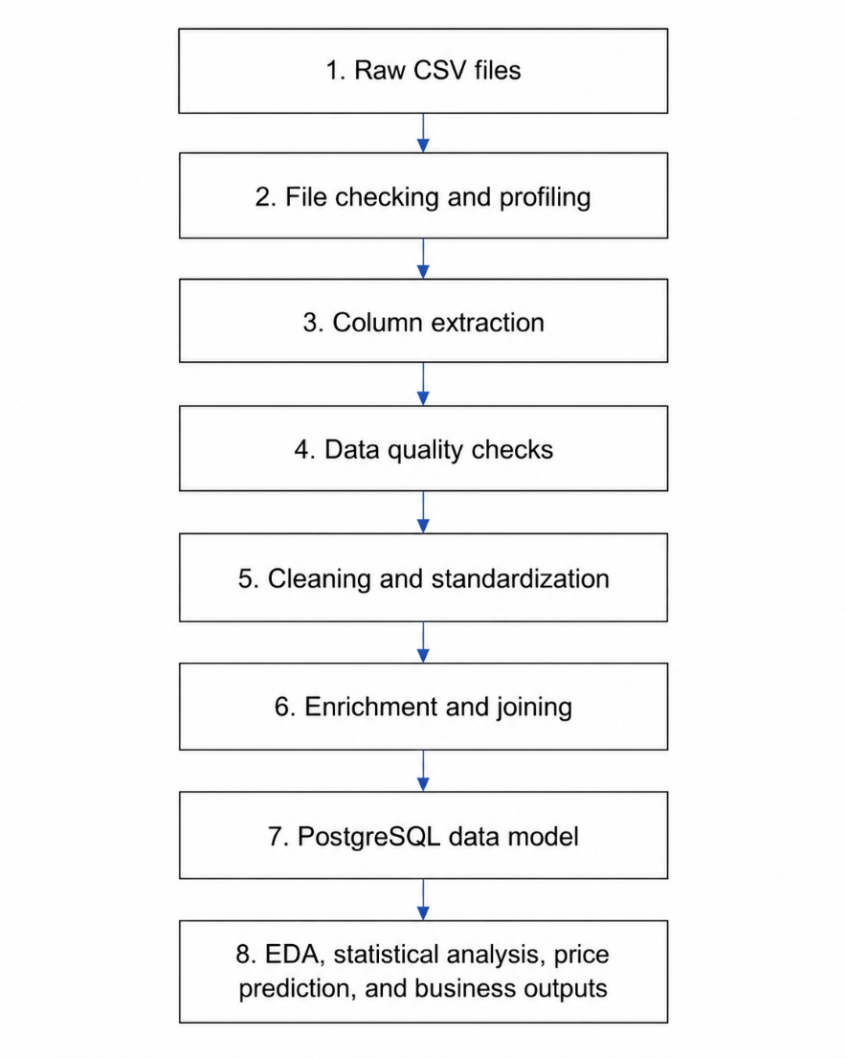

Folder Structure
The project was organized into separate folders based on purpose.
Folder | Purpose
data/raw/ | Stores original Inside Airbnb files before processing
data/processed/ | Stores extracted, cleaned, and enriched intermediate outputs
scripts/ | Stores Python scripts for ETL, analysis, and modeling
sql/ | Stores SQL queries used for PostgreSQL analysis
reports/ | Stores summary reports, data quality outputs, and final report files
figures/ | Stores EDA and modeling charts
exports/ | Stores open innovation output files
notebooks/ | Stores simple review and storytelling notebooks

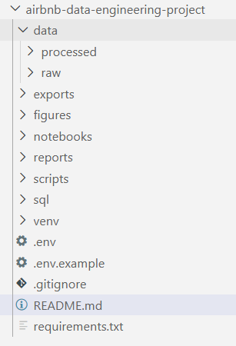
This structure separates raw data, processed data, source code, reports, and visual outputs. It also makes the project easier to navigate during review.
Figure 1: Folder Structure

Pipeline Design
The pipeline was divided into multiple scripts. Each script has one clear responsibility.
Step | Script | Purpose
1 | 01_check_files.py | Checks whether the required raw files exist and records file metadata
2 | 02_profile_data.py | Profiles datasets, including row counts, column counts, data types, missing values, and sample values
3 | 03_extract.py | Selects useful columns from the raw files and saves extracted outputs
4 | 04_quality_checks.py | Performs data quality checks such as missing values, duplicates, invalid values, and possible outliers
5 | 05_transform.py | Cleans and standardizes price, date, text, missing values, and geographic fields
6 | 06_enrich_join.py | Joins listings with calendar and review summaries to create enriched datasets
7 | 07_load_to_postgres.py | Loads the final analytical tables into PostgreSQL
8 | 08_eda_analysis.py | Creates exploratory analysis outputs and charts
9 | 09_statistical_analysis.py | Runs selected statistical tests
10 | 10_price_prediction.py | Runs a simple price prediction experiment
11 | 11_open_innovation.py | Creates rule-based business opportunity outputs

The run_pipeline.py script automates the main ETL steps from file checking to PostgreSQL loading. It also records a pipeline run log in the reports folder.

Data Ingestion
The ingestion process starts with raw files stored in data/raw/. The project expects the following files:
- listings.csv.gz
- calendar.csv.gz
- reviews.csv.gz
- neighbourhoods.csv
The file checking script confirms whether these files are available before the pipeline continues. This prevents later steps from failing unexpectedly because of missing input files.
The profiling script then reads the files and creates metadata reports. These reports help document the structure and quality of the raw data before cleaning.

Data Quality Checks
Data quality checks were performed before the main transformation stage. The checks included missing values, duplicate rows, possible duplicate listings, invalid prices, invalid availability values, and invalid coordinate values.
The purpose of these checks was to identify data issues early and document them clearly. The project avoids deleting many records automatically. Instead, suspicious or invalid values are flagged where possible.
This approach is useful because it preserves data traceability. Later analysis steps can decide which records should be included or excluded based on the analysis requirement.

Cleaning and Standardization
The cleaning step is handled by 05_transform.py. This script standardizes important fields used later in analysis.
The main cleaning actions included:
- Removing currency symbols and commas from price values
- Converting price into numeric format
- Parsing date fields into datetime format
- Cleaning text fields by trimming spaces
- Standardizing room type, property type, and neighbourhood fields
- Filling missing listing and host names with unknown
- Filling missing review count and review frequency values with 0
- Keeping missing review scores as null values
- Adding the selected city name as Amsterdam
- Rounding latitude and longitude to five decimal places
- Creating validation flags for suspicious or invalid records
The cleaning step also creates a validation summary and cleaning decision log. These outputs make the cleaning process more transparent and easier to review.

Enrichment and Joining
The enrichment step joins the cleaned datasets together and creates analysis-ready outputs.
The calendar file was summarized at listing level to calculate:
- Total calendar days
- Available days
- Estimated occupancy rate
The reviews file was summarized at listing level to calculate:
- review count
These summaries were joined with the cleaned listing data to create listing_master.csv. Additional derived fields were also created, including host tenure, price per bedroom, and estimated revenue.
The enrichment step also creates neighbourhood_summary.csv, which supports neighbourhood-level analysis.

PostgreSQL Data Model
PostgreSQL was used as the analytical database. A simple dimensional model was created to support SQL-based analysis.
The model includes:
Table | Description
dim_host | Host-level information
dim_listing | Listing-level descriptive information
dim_neighbourhood | Neighbourhood and city reference information
fact_listing_performance | Listing performance measures such as price, occupancy, revenue, review count, and rating
This model follows a simple star-style design. The dimension tables describe business entities, while the fact table stores measurable values.
The design was selected because it is easy to understand and suitable for analytical queries. It also demonstrates a common data warehousing concept without making the project unnecessarily complex.

SQL Analysis
The SQL file sql/03_analysis_queries.sql contains PostgreSQL analysis queries based on the final dimensional data model. These queries show how the cleaned and modeled data can be queried from the analytics schema.
The SQL queries support analysis questions such as:
- Checking row counts for the loaded PostgreSQL tables
- Average and median price by room type
- Price, rating, and estimated occupancy by neighbourhood
- Top hosts by listing count
- Top listings by estimated annual revenue
- Review score by room type
- Price per bedroom by room type
These queries demonstrate how the final tables, including dim_host, dim_listing, dim_neighbourhood, and fact_listing_performance, can support business-focused Airbnb analysis in a relational database.
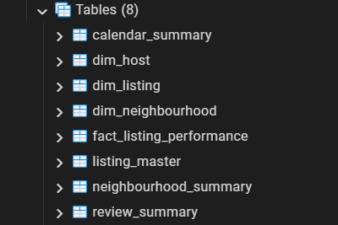
Figure 2: Table creation in PostgreSQL

Pipeline Automation and Logging
The run_pipeline.py script was created to run the main ETL steps in sequence. It records each step in reports/pipeline_run_log.csv.
The pipeline log includes:
- Step number
- Assessment section
- Script name
- Description
- Status
- Number of attempts
- Start time
- End time
- Duration
- Error message, if any
This makes the pipeline more transparent and easier to troubleshoot.

EXPLORATORY DATA ANALYSIS FINDINGS
Exploratory Data Analysis was used to gain insights into the primary trends of the Amsterdam Airbnb market. This analysis primarily looked at listings prices, room type differences, neighbourhood differences, availability differences, host activity and relationships between review scores.
The primary EDA results were generated from the enhanced listing-level dataset and saved as CSV Report and Chart images in the `reports/` and `figures/` folders.

Overall Listing Summary
The final enriched dataset consisted of 10,480 listings in Amsterdam. From these, 5,874 listings contained good cleaned price values and were used for price-based analysis.
The median price of the list was 222.00, the average price of the list was 336.79. The average price was higher than the median price indicating a right-skewed price distribution. The vast majority of listings are lower-mid level, with a few high dollar listings driving up the average.
Guest ratings of listings that have been reviewed are generally high: the average score is 4.84.

Price Distribution
The distribution of prices revealed that the price of Airbnb properties in Amsterdam is not normal. The majority of listings fall within the lower and mid-range of prices, and a smaller proportion of listings are very expensive.
This is a typical trend in the field of accommodation. Most of the times, with standard private rooms and apartments, one will have a relatively low price value, but luxury homes, large properties and premium locations will generate very high prices.
Due to this imbalanced distribution, it is better to use the median price than the average price to describe the typical Airbnb listing price.
Before creating selected EDA charts and average price summaries, very high price values were handled separately. The 99th percentile price value, 991.62, was used as the EDA outlier threshold. Prices above this value were not deleted from the dataset, but they were excluded from selected charts and average summaries to avoid a small number of extreme prices distorting the interpretation.
In total, 59 out of 5,874 valid price records were flagged as EDA price outliers. The median price was still used as the main comparison measure because it is more stable for skewed price data.
Table 1: EDA Summary
total_listings | listings_with_price | median_price | average_price | average_price_without_eda_outlier | average_review_score | average_occupancy_rate
10480 | 5874 | 222.00 | 336.79 | 252.66 | 4.84 | 0.74
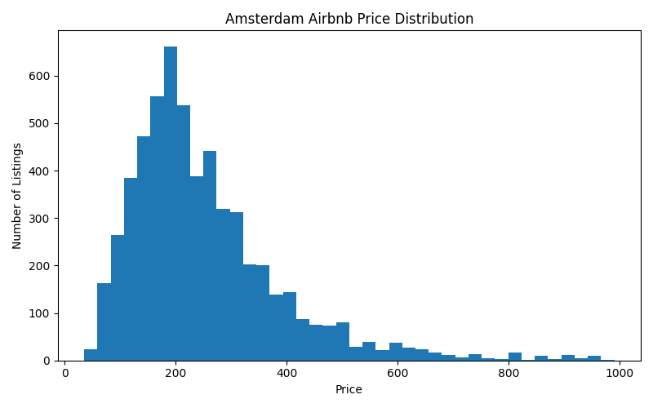
Figure 3: Price Distribution

Price by room type
Room type was one of the clearest pricing factors in the dataset. Entire homes and apartments had the highest median price, followed by hotel rooms, private rooms, and shared rooms.
This result is expected because entire homes and apartments usually provide more privacy, space, and control for guests. Private rooms are usually more affordable because the guest may share part of the property with the host or other guests.
The hotel room category needs careful interpretation. It had only 38 listings, and a few extreme price values affected the raw average price. After applying the EDA outlier handling step, the average hotel room price became more reasonable. Therefore, median price is the better value to use when comparing room types.
From a pricing point of view, hosts should compare their listings with similar room types instead of comparing against the full Amsterdam market. Entire home hosts may be able to charge higher prices, while private room hosts may need to compete more on affordability, location, and guest experience.
Table 2: Room type price summary
room_type | listing_count | median_price | average_price | Outlier_count
Entire home/apt | 4532 | 248 | 279.15 | 51
Hotel room | 38 | 231 | 209.3 | 5
Private room | 1274 | 139 | 163.27 | 3
Shared room | 30 | 95.5 | 130.27 | 0
Figure 4: Price by room type
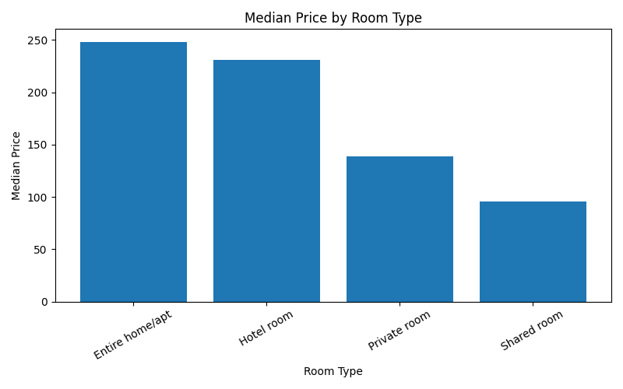

Neighbourhood Price Differences
The analysis at neighbourhood level revealed a distinct price gap between neighbourhoods in Amsterdam. Certain neighbourhoods were more pricey and some were more affordable.
This indicates that there is a spatial effect in terms of Airbnb price. Neighbourhood listings in more central, popular or in-demand areas might command higher prices. The prices may be lower in more residential or less central neighbourhoods, but this might still make them desirable if they have high or good ratings or have a high level of occupancy.
A business perspective of neighbourhood analysis can be used to help identify premium areas and value areas, as well as investment opportunities.
Table 3: Top neighbourhoods by median price
neighbourhood_cleansed | listing_count | median_price | average_rating
De Pijp - Rivierenbuurt | 649 | 250.00 | 4.86
Centrum-West | 770 | 245.50 | 4.82
De Baarsjes - Oud-West | 992 | 240.00 | 4.86
Centrum-Oost | 580 | 240.00 | 4.82
Zuid | 435 | 238.00 | 4.87
Oud-Oost | 326 | 222.00 | 4.82
Westerpark | 392 | 214.50 | 4.84
Watergraafsmeer | 138 | 213.50 | 4.85
IJburg - Zeeburgereiland | 107 | 198.00 | 4.85
Oud-Noord | 252 | 196.50 | 4.80
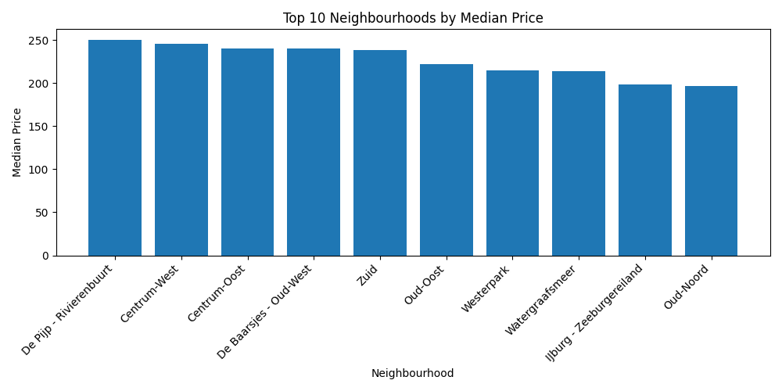
Figure 5: Top neighbourhoods by price

Availability and Estimated Occupancy
Occupancy patterns were estimated from the calendar availability. The average estimated occupancy rate was 0.74.
This indicates that for a significant part of the calendar period many listings seemed to be unavailable, due to the calendar availability data. If the date is not available, it doesn't necessarily mean that the room or apartment was booked on that day. It is also possible that the date was manually blocked by the host or for a limited period of time, the host has removed availability.
Therefore, the results of occupancy and revenue for this project should be seen as estimates and not as values of confirmed business performance.
Table 4: Monthly availability
month | average_availability
2025-09 | 15.27
2025-10 | 21.78
2025-11 | 29.56
2025-12 | 29.44
2026-01 | 30.44
2026-02 | 31.52
2026-03 | 28.27
2026-04 | 25.67
2026-05 | 27.27
2026-06 | 23.21
2026-07 | 22.13
2026-08 | 22.43
2026-09 | 22.93
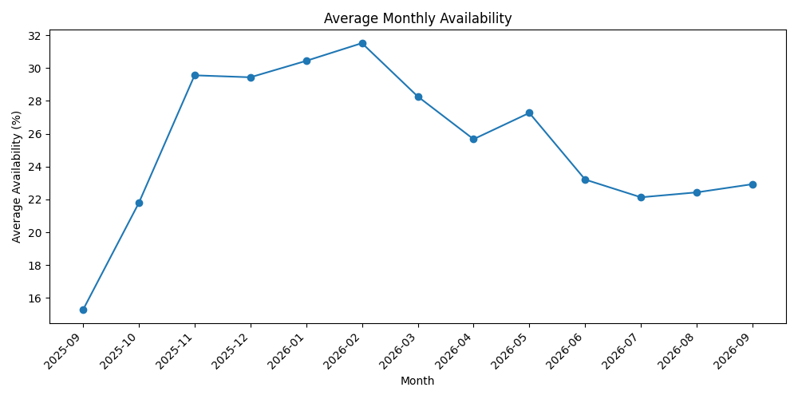
Figure 6: Monthly availability

Host Activity
Host analysis revealed that both individual hosts and multiple-hosts are part of the Amsterdam Airbnb market.
Many hosts seem to have just one listing, and some hosts have multiple listings. More professional or portfolio style hosting activity may be taken as being represented by hosts that have multiple listings.
This is helpful because there are different pricing, availability, and operational models for individual hosts and professional hosts.
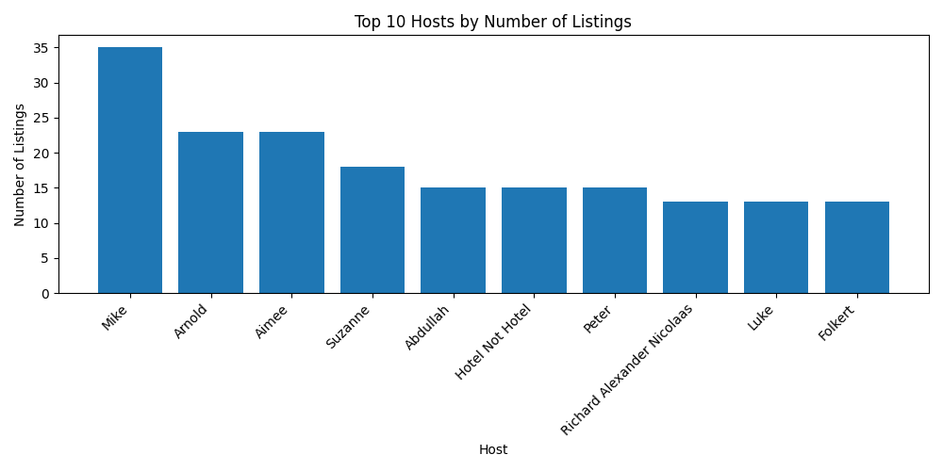
Figure 7: Top hosts by listing count

Review Score Patterns
The scores of reviewed items were mostly high in of the data set. The average review rating was 4.84, indicating guests were highly satisfied with the properties they have been staying in.
But the high review ratings do not necessarily equate to higher prices. The price depends on several factors such as the type of rooms, the neighborhood, the property size, the capacity of guests, property availability, and host strategy.

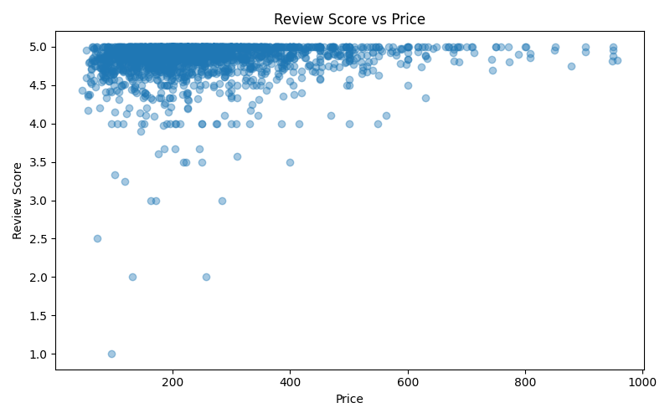
It should be understood that the review score is one part of the pricing factor, and not the sole factor.
Figure 8: Review score vs price

Review Count as a Demand Indicator
Count of reviews served as an approximation of the number of requests for each service. The number of reviews might indicate a guest's activity in the listing over time.
Review count does not equal booking count, however. Not all guests write a review and older listings of course have more time to gather reviews. So, be wary of the use of review count when considering demand.

STATISTICAL FINDINGS
Basic statistical analyses were done to determine the statistical significance of selected Airbnb market patterns. The aim was to determine the p-values, but also to interpret the values in terms of business.
The statistical analysis was on price differences, review score difference, review activity and neighbourhood price difference. Tests were conducted on the cleaned and enriched listing dataset of Amsterdam.

Statistical Testing Approach
Airbnb pricing data has typically been skewed, since the vast majority of listings are in a normal range, with a relatively small number of luxury and large listings that have drastically higher prices. For this reason, the Mann-Whitney U test was performed instead of the average values.
A one-way ANOVA test was applied to compare the prices in the different neighbourhoods.
Both statistical significance and practical difference was analyzed. A statistical significance result determines if the difference between two sets of data is likely to be real and a practical difference is the meaningfulness of the difference for business interpretation.

Hypothesis 1: Entire Homes vs Private Rooms
Question: Do entire homes and private rooms have different prices?
Group | Count | Median Price
Entire home/apt | 4,532 | 248.00
Private room | 1,274 | 139.00

The Mann-Whitney U test found a statistically significant difference between the prices of entire homes/apartments and private rooms.
The practical difference between the median prices was 109.00. Entire homes and apartments had a much higher median price than private rooms.

Business interpretation:
Room type is one of the strongest pricing factors in the Amsterdam Airbnb market. Entire homes and apartments can usually be priced higher because they offer more privacy, more space, and a more complete accommodation experience. Private rooms are generally positioned as a more affordable option.

Hypothesis 2: Superhost vs Non-Superhost Review Scores
Question: Do superhost and non-superhost listings have different review scores?
Group | Count | Median Review Score
Superhost | 1,813 | 4.90
Non-superhost | 7,460 | 4.94

The Mann-Whitney U test found a statistically significant difference between superhost and non-superhost review scores.
However, the practical difference was very small. The median review score for superhosts was 4.90, while the median review score for non-superhosts was 4.94.
Business interpretation:
Although the difference was statistically significant, it is not large enough to be a strong business conclusion by itself. Review scores are generally high across the dataset, so the superhost label alone may not fully explain guest satisfaction. Other factors such as listing quality, location, price, and guest expectations may also influence ratings.

Hypothesis 3: Listings With More Reviews vs Fewer Reviews
Question: Do listings with more than 10 reviews have different prices compared with listings with 10 or fewer reviews?
Group | Count | Median Price
More than 10 reviews | 3,054 | 207.00
10 or fewer reviews | 2,820 | 234.00

The Mann-Whitney U test found a statistically significant difference between the two groups.
Listings with more than 10 reviews had a lower median price than listings with 10 or fewer reviews. The practical difference was -27.00.
Business interpretation:
Listings with more reviews may not always be more expensive. One possible explanation is that more affordable listings receive more bookings and therefore collect more reviews over time. Another explanation is that newer or premium listings may have fewer reviews but higher prices. This shows that review count should be treated as a demand indicator, not a direct price indicator.

Hypothesis 4: Price Differences Across Major Neighbourhoods
Question: Do prices differ across major neighbourhoods?
A one-way ANOVA test was performed using the top five neighbourhood groups by listing count. The test found a statistically significant difference in prices across major neighbourhoods.
The p-value was 0.004567, which supports the conclusion that neighbourhood pricing differences exist in the dataset.
Business interpretation:
Neighbourhood is an important pricing factor in the Amsterdam Airbnb market. This supports the EDA finding that location affects listing value. Hosts and analysts should consider neighbourhood-level pricing patterns when evaluating pricing strategy or market opportunity.

Hypothesis 5: Weekend vs Weekday Prices
Question: Are weekend and weekday prices different?
This test was not performed because the calendar.price and calendar.adjusted_price fields were missing in the Amsterdam dataset.
Business interpretation:
The dataset did not support reliable daily price comparison. Listing-level price was available, but daily calendar prices were not. Therefore, weekday-versus-weekend price analysis was excluded to avoid making unsupported conclusions.

Summary of Statistical Findings
Hypothesis | Result | Business Meaning
Entire homes vs private rooms | Significant difference found | Room type strongly affects price
Superhost vs non-superhost review scores | Significant difference found, but small practical difference | Superhost status alone does not strongly explain rating differences
More than 10 reviews vs 10 or fewer reviews | Significant difference found | Review count may indicate demand, but not necessarily higher price
Neighbourhood price differences | Significant difference found | Location is an important pricing factor
Weekend vs weekday prices | Not performed | Calendar price data was missing

Overall, the statistical findings support the main EDA conclusions. Room type and neighbourhood are important drivers of Airbnb pricing in Amsterdam. Review activity also provides useful context, but it should be interpreted carefully because reviews are not the same as confirmed bookings.

DATA SCIENCE EXPERIMENT - PRICE PREDICTION
This project's data science element was a simple pricing prediction experiment was completed. The aim was to assess if specific Airbnb listing characteristics were able to predict the price of a listing in Amsterdam.
The prediction task was formulated as a regression problem. The model output target variable was `price_clean`, which is the numeric listing price after cleaning.

Features Used
The selected features for the model were from the cleaned and enriched listing dataset and included the following:
- Room type
- Property type
- Neighbourhood
- Accommodates
- Bedrooms
- Beds
- Availability_365
- Review score
- Review count
- Estimated occupancy rate
One hot encoding was used to transform categorical features to a numeric format. The experiment was conducted with only records that contain valid prices.

Models Compared
Two models were compared:
Model | Purpose
Linear Regression | Simple baseline model
Random Forest Regressor | Non-linear comparison model

Linear Regression was used because it is simple and easy to interpret. Random Forest was used because it can capture more complex relationships between listing features and price.

Model Results
Model | Cross-Validation MAE | Test MAE | Test RMSE | Test R²
Linear Regression | 68.42 | 67.77 | 97.20 | 0.5179
Random Forest | 67.11 | 66.79 | 96.61 | 0.5237

The Random Forest model performed slightly better than Linear Regression. It had a lower test MAE, lower RMSE, and slightly higher R² value.
However, the improvement was small. This means the Random Forest model was better, but not significantly enough to treat it as a final production pricing model.

Interpretation
The Random Forest model had a test MAE of 66.79. This indicates that the model's prediction on prices are about 66.79 off on average.
The R² value was 0.5237, which accounts for approximately 52% of the variance in the listing prices. This is a plausible outcome from the collection of public Airbnb data for a simple experiment.
Accommodates, Bedrooms, Availability, Room Type, Room Reviews, Room Score, and Estimate Occupancy Rate were important features. Business sense is these results as larger listings, various room types, and higher indicators of demand can impact price.

Limitations
There are some shortcomings to this experiment. It only included Amsterdam data, calendar prices were not provided and occupancy was calculated by subtracting availability from 100. Other deeper factors, such as amenities, photo quality, exact location attractiveness, and seasonal demand were also not included in the model.
Overall, this price prediction experiment revealed that simple listing characteristics account for some of the variation in Airbnb prices. The model can be used as an exploratory analysis but is not an actual tool for pricing production.

Table 5: Top feature importance values
feature | importance
accommodates | 0.33
bedrooms | 0.09
availability_365 | 0.09
room_type_Private room | 0.07
review_count | 0.07
review_scores_rating | 0.06
occupancy_rate | 0.04
neighbourhood_cleansed_Centrum-West | 0.04
beds | 0.03
neighbourhood_cleansed_Centrum-Oost | 0.03
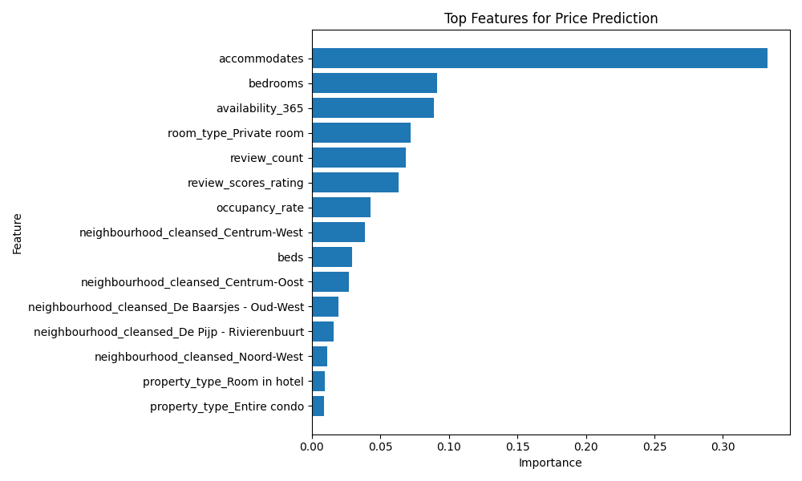
Figure 9: Price prediction feature importance

OPEN INNOVATION CHALLENGE
A small rule-based Market Opportunity Finder was created. It identifies value neighbourhoods, premium neighbourhoods, high occupancy areas, listings that may need improvement, and top estimated revenue listings.
Value neighbourhoods
neighbourhood_cleansed | listing_count | avg_price | avg_rating | avg_occupancy
Slotervaart | 206 | 193.24 | 4.88 | 0.82
De Aker - Nieuw Sloten | 67 | 185.71 | 4.86 | 0.71
Noord-Oost | 188 | 191.05 | 4.86 | 0.73
Noord-West | 298 | 196.99 | 4.86 | 0.75
Oostelijk Havengebied - Indische Buurt | 436 | 216.60 | 4.86 | 0.80
Osdorp | 57 | 168.62 | 4.86 | 0.69

Premium neighbourhoods
neighbourhood_cleansed | listing_count | avg_price | avg_rating | avg_occupancy
Buitenveldert - Zuidas | 125 | 3013.22 | 4.82 | 0.64
IJburg - Zeeburgereiland | 188 | 1730.39 | 4.85 | 0.76
Oud-Noord | 485 | 370.50 | 4.83 | 0.78
Centrum-West | 1207 | 315.88 | 4.80 | 0.68
Zuid | 735 | 309.58 | 4.88 | 0.73
Centrum-Oost | 923 | 307.72 | 4.81 | 0.64
De Pijp - Rivierenbuurt | 1199 | 280.47 | 4.86 | 0.73
De Baarsjes - Oud-West | 1808 | 271.28 | 4.87 | 0.77
Watergraafsmeer | 318 | 268.30 | 4.86 | 0.77
Westerpark | 736 | 255.04 | 4.86 | 0.78

High occupancy neighbourhoods
neighbourhood_cleansed | listing_count | avg_price | avg_rating | avg_occupancy
Bos en Lommer | 547 | 204.67 | 4.84 | 0.82
Slotervaart | 206 | 193.24 | 4.88 | 0.82
Bijlmer-Oost | 38 | 157.36 | 4.79 | 0.81
Oostelijk Havengebied - Indische Buurt | 436 | 216.60 | 4.86 | 0.80
Westerpark | 736 | 255.04 | 4.86 | 0.78
Oud-Oost | 654 | 251.66 | 4.85 | 0.78
Oud-Noord | 485 | 370.50 | 4.83 | 0.78
Watergraafsmeer | 318 | 268.30 | 4.86 | 0.77
De Baarsjes - Oud-West | 1808 | 271.28 | 4.87 | 0.77
IJburg - Zeeburgereiland | 188 | 1730.39 | 4.85 | 0.76

BUSINESS RECOMMENDATION
From the data engineering output, exploratory analysis, statistical results, and experiment on predicting prices, a number of business recommendations can be made regarding Airbnb hosts, analysts, and market decision makers.

Use Median Price for Market Benchmarking
The Airbnb price distribution of Amsterdam is skewed to the right. The average is higher than the median price since there are some of the high-priced listings that raise the average price.
For this reason, it is advisable to compare typical listing prices by using median price. Don't use the average price as the only indicator since this can give hosts the false sense of what they can charge for an average listing.
Recommendation: Use median price by room type and neighbourhood as the main pricing benchmark

Price Listings Based on Room Type
Room type was one of the strongest pricing factors. Entire homes and apartments had higher prices than private rooms.
This means hosts should compare their listing against similar room types instead of comparing against the whole market.
Recommendation:Hosts should benchmark prices separately for entire homes, private rooms, shared rooms, and hotel rooms.

Consider Neighbourhood-Level Pricing
By analysing neighbourhoods, it was determined that there are differences in price throughout Amsterdam. The cost of some areas is higher, others lower.
This implies that one price policy for the whole region is not enough.
Recommendation: Use neighbourhood-level summaries to identify premium areas, value areas, and potential growth opportunities.

Treat Occupancy and Revenue as Estimates
Calendar availability was used to estimate occupancy and revenue. However, unavailable dates may represent actual bookings or dates blocked by hosts.
Because of this, estimated occupancy and estimated revenue should not be treated as confirmed business performance.
Recommendation: Use occupancy and revenue estimates for directional analysis only. For stronger business decisions, confirmed booking and transaction data would be needed.

Improve Listings with Many Reviews but Lower Ratings
The open innovation output identified listings that have many reviews but lower review scores. These listings may already have demand, but they may also have quality or guest experience issues.
Recommendation: Hosts should review listings with high review counts and lower ratings to identify improvement opportunities in cleanliness, communication, amenities, or value for money.

Use Price Prediction as a Support Tool, not a Final Decision Tool
The price prediction experiment showed that listing features can explain part of the variation in price. However, the model is not accurate enough to be used as an automatic pricing system.
Recommendation: Use the model as a supporting tool to understand pricing drivers, but combine it with human judgment, market knowledge, and updated booking data.

Focus on Practical Pricing Drivers
The analysis showed that price is influenced by several practical factors, including room type, neighbourhood, capacity, bedrooms, availability, review activity, and review score.
Recommendation: When evaluating a listing, consider multiple factors together instead of focusing on only one metric such as rating or review count.

Summary of Recommendations
The key business recommendations are:
- Use the median price rather than average for typical comparisons.
- Check prices for different types of rooms.
- Make a comparison of the listings in the same community.
- Assume that occupancy and revenue are not actual outcomes.
- Enhance listings that have numerous reviews and a poor rating.
- Price prediction is a tool to support, not serve as the basis for trading.
- Take multiple pricing drivers into account.
In general, the analysis indicates that the price of Airbnb in Amsterdam primarily depends on the type of room, location, the number of available spaces, the availability of the room, and indicators related to the reviews.

CROSS-CITY COMPARISONS
Cross-city comparison was not included in this project because the selected scope focused only on Amsterdam.
Amsterdam was selected because the dataset was large enough to demonstrate practical data engineering challenges, including large calendar files, missing values, data cleaning requirements, joins across multiple files, and analytical modeling.

LIMITATIONS & CAVEATS
There are a number of significant constraints in this project.
- First, the analysis was completed for Amsterdam only. More city-level analysis is needed before findings can be generalized to other Airbnb markets.
- Secondly, the data set is publicly available snapshot of Airbnb data. It is not intended to be a full history of bookings, transactions or host activity.
- Thirdly, availability doesn't guarantee bookings in the calendar. If there is no date available, this could be because the listing has already been booked, or it could be that the host decided not to accept the date. Therefore, estimated occupancy and estimated revenues should be used as an approximation.
- Fourth, the fields “calendar price” and “adjust price” were not present. As a result, a daily price analysis and price testing between weekdays and weekends was not possible.
- Fifth, count is not the same as count of books. It is possible that some visitors might not post a review, and older listings may have had a longer time to garner reviews. Only count of reviews was used as a proxy for demand
- Sixthly, the price prediction experiment was a simple exploration. Did not contain the depth of features like amenities, photo quality, exact location attractiveness, seasonality or confirmed booking data.
- Last, some missing values were retained to prevent the creation of artificial information. This is suitable for analysis integrity, but also means that some analyses only utilized records with valid values.

FUTURE IMPROVEMENTS
This project could be enhanced in a number of ways with the benefit of additional time, more information and more resources.
- The first is that this pipeline could be extended to provide for several cities. This would enable the ability to compare pricing, room type distribution, availability, reviews and neighbourhood level market behavior across cities.
- Second, occupancy and revenue analysis would be improved by the fact that the confirmed booking and transaction data would be there. This would increase the reliability of the revenue estimates as compared to calendar availability.
- Third, prices on the daily calendar would enable the analysis of pricing trends by day of the week, season, and significantly more detailed analysis.
- The fourth change was that the price prediction model could be enhanced with more features like amenities, cancellation policy, minimum stay, host response behavior, property quality, review text sentiment, and distance from the city center.
- Fifth, it is possible to develop a dashboard for business users. Some of the insights that could appear on this dashboard include average price, median price, occupancy estimate, top neighbourhoods, room type comparison, and opportunities to improve listings.
- Sixth, the engineering workflow could be enhanced by using Docker, automated tests, data validation tools, workflow orchestration and scheduled runs of the pipeline.
In general, this project could be improved to make it more automated and reusable as an assessment analytics workflow for future projects.

REFLECTION
It was an excellent project to learn how a real-life data engineering project is not a mere coding exercise. It involves an understanding of data, a sense of limitations, decision making, documentation of assumptions and clear communication of results.
An important lesson was that public data sets can frequently be incomplete or inaccurate. For instance, some price fields in the calendar were not there and dates that didn't exist on the calendar were not able to verify bookings. This meant that it was important that there was no overclaiming and that there was a clear explanation of limitations.
Another lesson learnt was the value of prioritization. The assessment was very generic, and so I concentrated on finishing the primary data engineering workflow correctly. I only chose "Amsterdam" and wrote a basic ETL pipeline, generated analytical outputs, loaded data into PostgreSQL, and included EDA, statistical testing, and a mini price forecasting experiment.
I also found that basic things can work well and be informative when clearly explained. In the project, there was no use of advanced cloud tools or the use of complex machine learning systems, but these were shown to be important data engineering skills like profiling, cleaning, joining, modelling, automation and reporting.
In general, I emphasized interpretation, reproduction and clarity. A practical end-to-end workflow that demonstrates how raw Airbnb files can be transformed into structured outputs and business insights.

APPENDIX A: AI USAGE DISCLOSURE
AI tools were used as support during this project. They assisted in the comprehension of the assessment requirements, the development of the project structure, code logic review, documentation construction and in enhancing the wording of the report.
The following areas of the document were assisted by AI:
- Breaking down the assignment requirements
- The process of organizing the folder structure.
- Scanning the flow of the ETL pipeline
- Reviewing Code
- Enhancing data cleaning documentation.
- Drafting readme content
- Drafting report sections
- Providing explanation about project files and assessment sections

